Frederick by Leo Lionni, published in 1967 by Scholastic Incorporated, is a story about a mouse named Fredrick. While all the other mice are gathering food for the winter, Frederick decides to gather some unusual items. The other mice think that he is lazy for doing this, but he has a special surprise for the them (Frederick).

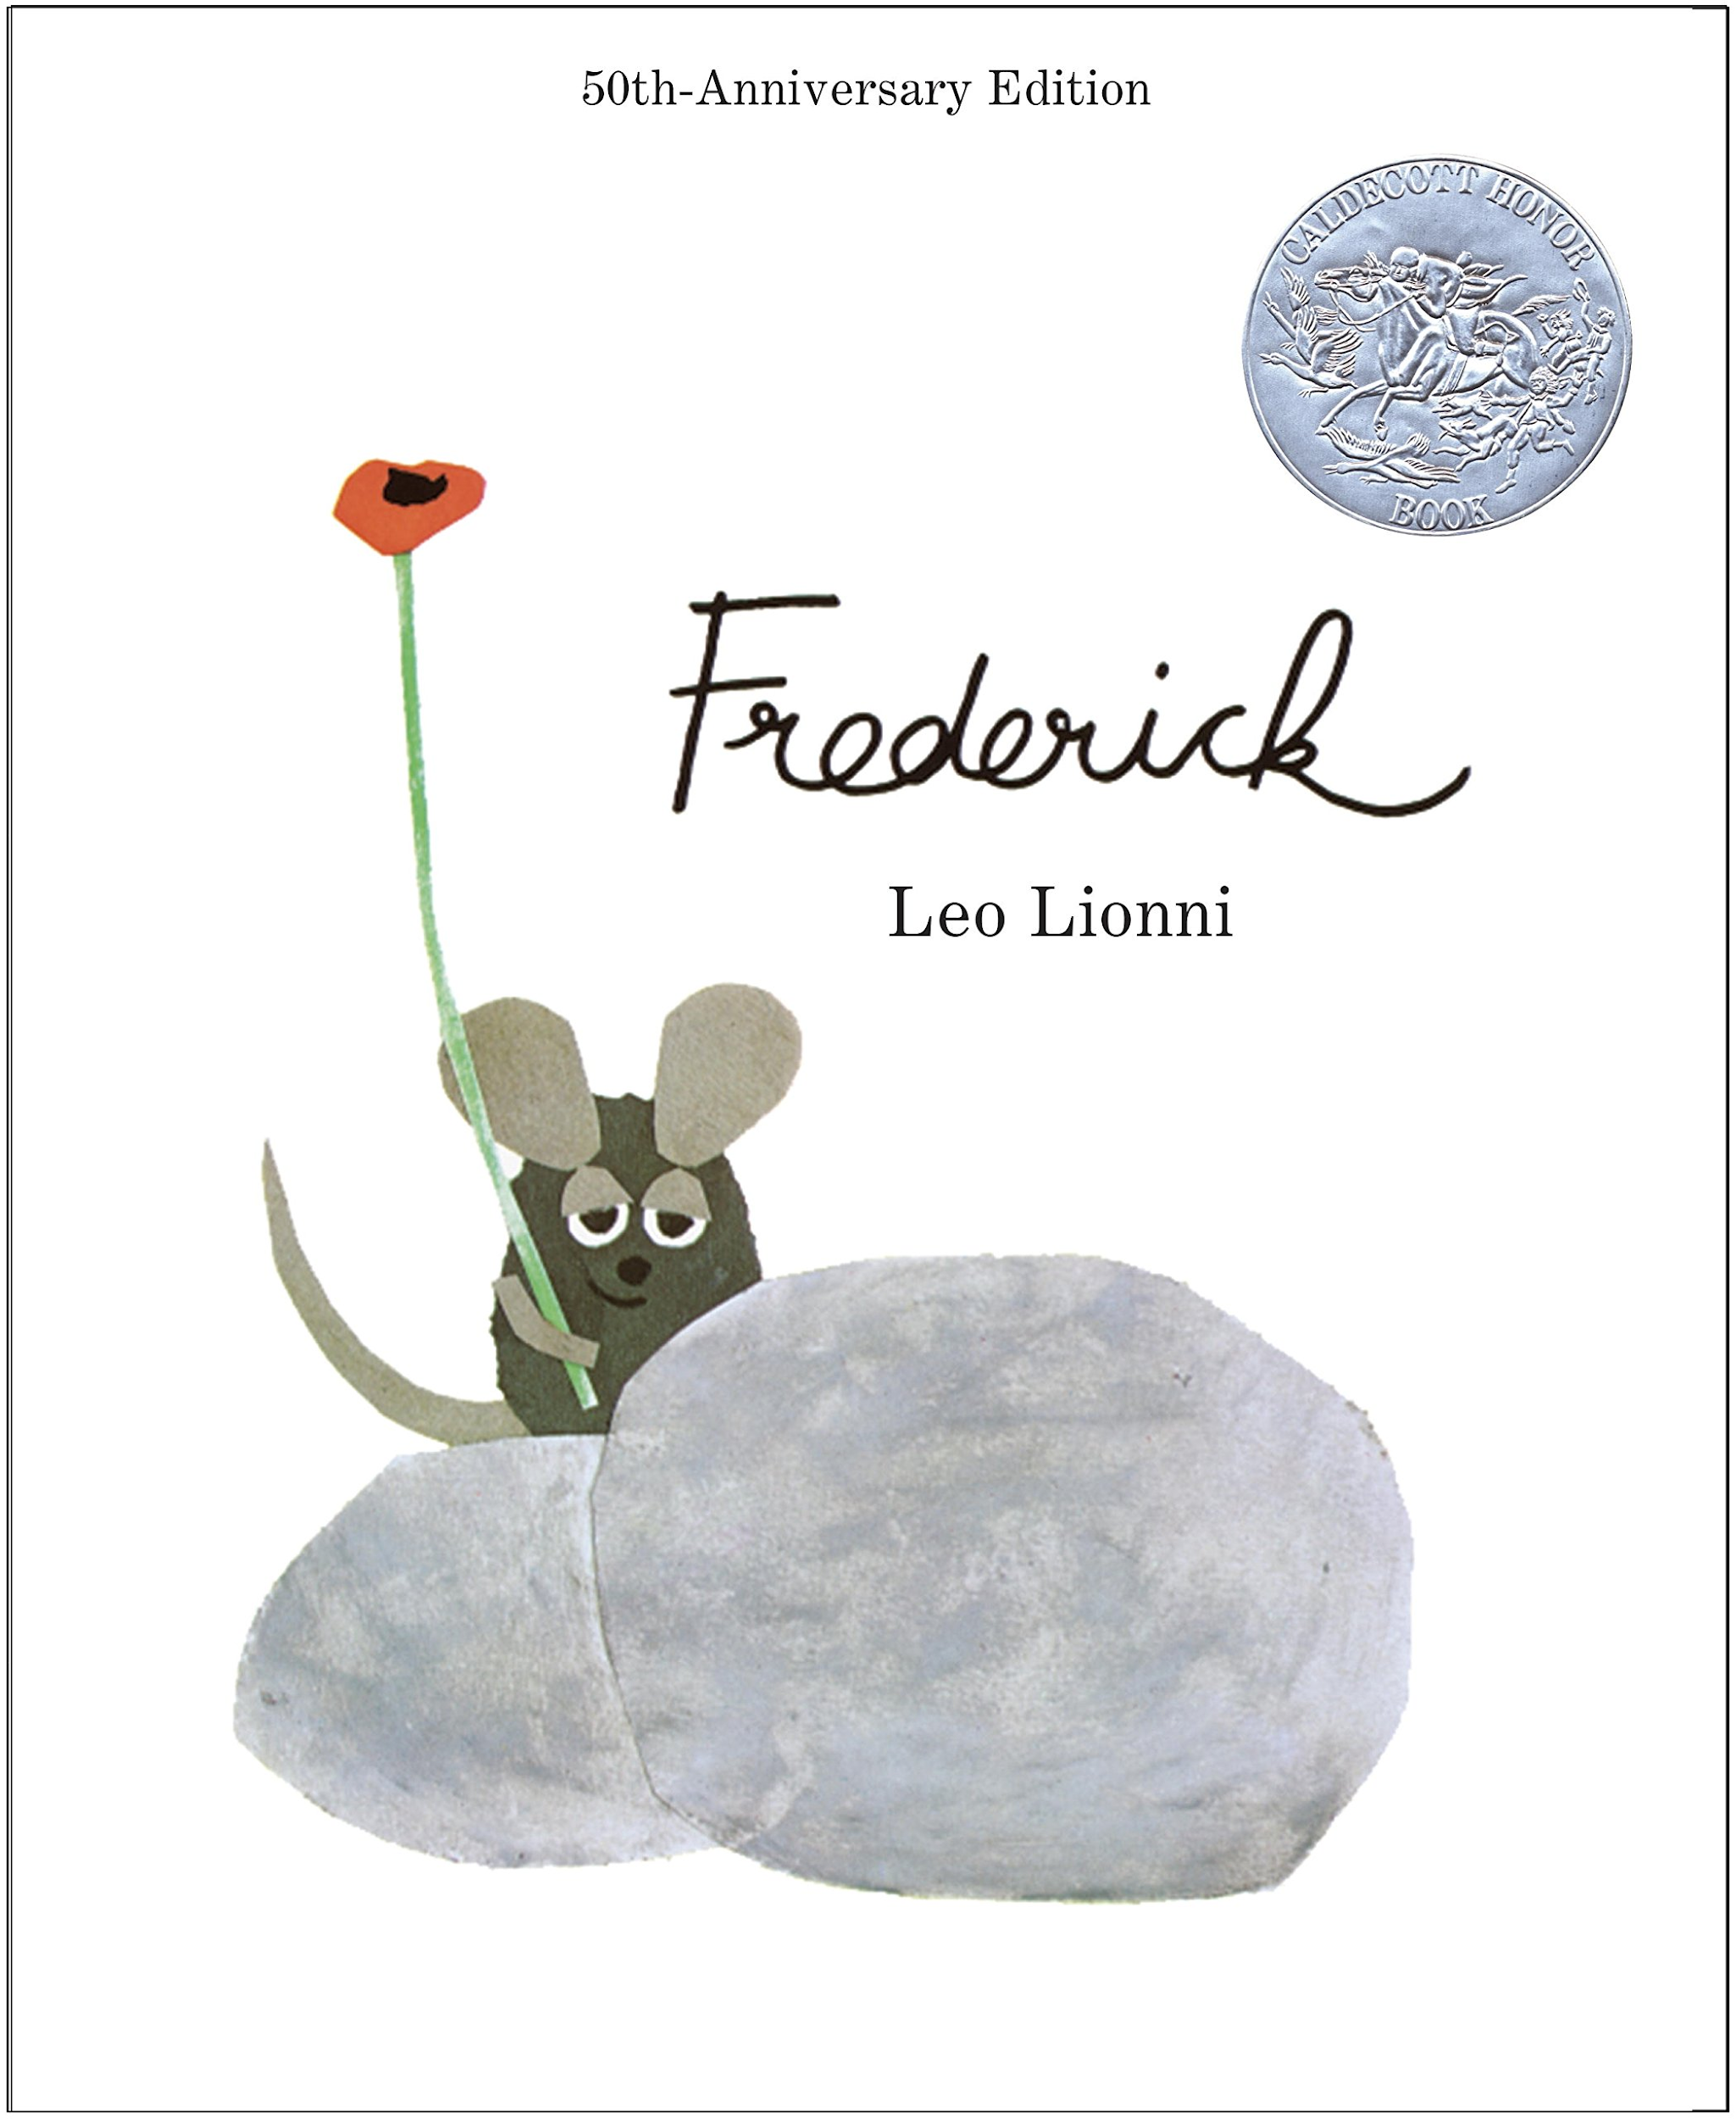

Colours Captured in Time
Based on Frederick by Leo Lionni
By: Kathryn Ebert, Kate Schmidt, and Charlotte Junker

Why Did We Choose This Story?
We chose this story because it offers a lot of opportunity for engaging with both written and visual components. This story also allows for students to explore some bigger themes/questions such as:
- Understanding others feelings
- Thinking outside the box
- Making personal connections
- Thinking of yourself and others
- Looking at the importance of community

Key Understandings and Questions

- What makes a community?
- It is important to consider the needs of others as well as yourself

Drama Learning Outcomes (Grade 5)

- Participate in a variety of drama forms
- Use a variety of vocal elements and movement elements to communicate meaning
- Demonstrate collaborative skills during drama

Cross-curricular outcomes (Grade 5)

- Physical and Health Education - Describe and assess strategies for promoting mental well-being, for self and others. “Mind painting” is an activity student’s can use by themselves with their eyes closed. I think it would be beneficial for a student to do if they are having a hard time falling asleep.
- English Language Arts - Develop and apply expanding word knowledge during the activity “if the colour fits”. Students have the opportunity to develop and apply words for many shades of colours.

The specific points the activities take place in the story are included at the end of our assignment.

1. If the colour fits 5 minutes

Grouping: Whole class seated in a circle
Strategy: Category Game
Administration: None
Focus: To draw attention to the diversity of colours that make students happy

Teacher: To start our drama off today, we are going to play a game that will require
you to think about some colours that make you happy.
Everyone, line up on this side of the room. [They do]
Good.

I am going to call our different colours and if the colour brings you joy,
your task is to cross the floor. Remember to listen and think carefully
before you respond. For example, let’s try this one:
- Cross the floor if yellow makes you happy. [Some do]
Good. Any questions?
Now let’s try some more:
- Cross the floor if blue makes you happy
- … if green makes you happy
- … if red makes you happy

You can ask the students to notice how some of their classmates have different colours that make them happy.

- Cross the floor if brown makes you happy
- … if black makes you happy
- … if white makes you happy
- … if beige makes you happy

Continue on with discovering the diverse amount of happy colours. Remind students that they can have multiple colours that make them happy.

- Cross the floor if turquoise makes you happy
- … if magenta makes you happy
- … if pastel yellow makes you happy
- … if pastel blue makes you happy

Awesome! Everyone come back to the circle and turn to the person next to
you. Talk about what you noticed about the diversity of favourite colours
in our classroom. [They do]

They may want to talk about the colours that made the most people happy, and the colours that didn’t make many people happy.

If your friend was upset, and you wanted to cheer them up with a drawing
or painting, would you use colours that make you happy or colours that
didn’t make you happy in that drawing? [They discuss]

2. Frozen in time 10 minutes

Grouping: Groups of five
Strategy: Tableau
Administration: None
Focus: To express thoughts and feelings in stillness

Teacher: Please form groups of five. [They do]
We are going to create an image of what we just heard by working in
Tableaux - showing visual images with our bodies.

In your groups, we will create Frederick and the mice working to get ready
for winter. These creations will either be Frederick sitting looking
toward the field; the mice with big pieces of food on their back; the mice
looking toward Frederick wondering what he is doing; the mice preparing
for Winter in the cave or some other place that would be an interesting
background for the mice.

This picture will show a group of mice at a moment in time. All of them
will be ‘working’ except for one, Frederick. What do the mice look like?
Create a still picture that shows how the mice are feeling without moving
or speaking.

The mice should be frozen doing something. Your still picture could make
it obvious who Frederick is, or it can be subtle. Any questions?

You only have about three minutes - so start working!

Allow more time if needed. When ready,

Teacher: We will now view your still picture creations. We will see how they show
each mice’s feelings.
Who would like to begin? [A group offers]
Thank you.

We will close our eyes as the first group gets into position. When the
group is ready, I will count down, three-two-one and say “open”. We will
look at the frozen groups tableau to see how the mice in the picture are
feeling.

Extend the tableau work with the next activity. Then continue viewing and discussing each group's tableaux.

3. Making the picture speak 5 minutes
Grouping: As above
Strategy: Tapping in
Administration: None
Focus: To discover what thought lie beneath the picture

You can choose to use tap in with every group, or just one or two.

Teacher: Hold your tableau. When I come around and put my hand on your
shoulder, share the thought that is in your mind. The thought or feeling
will be that of your character in the tableau.

With your hand on the students shoulder, wait until the student has a chance to speak. If the student doesn’t speak, don’t worry. Give them enough time to speak and then move on without comment. Be sure not rush, and to give everyone enough time to express their character.

Remind students that they only need to say a few words. When you lift your hand, it helps to remind students that they can stop speaking. You may also choose to only ask some group members to speak.

Some students watching may wish to contribute to tapping in themselves, or by asking questions. Some examples of questions may be:

- How long have you been working to prepare for Winter?
- What are you gathering?
- What colours are you collecting?
- What words are you collecting?

Thank you for all of your contributions. We are beginning to understand
what the mice are doing, thinking and feeling. Now the next group will
add to our understanding!

Continue until all groups have been seen (and heard).

Teacher: Isn’t it fascinating how creating still pictures help us to understand
a story deeper?
Let’s go back to the story to find out more about Frederick and the mice.

4. Visualizing the story 7 minutes

Grouping: Pairs
Strategy: Sculpting
Administration: Clear space to move in
Focus: To interpret words into an image

Teacher: Everyone please find a partner and move into your own space in the room. We will need 1 person in the pair to be the sculptor and the other partner will be the one who is sculpted.
You will each have 1-2 minutes to sculpt your partner into a mouse who is collecting their supplies and bringing them back. You can move your partners arms and legs, and direct them as to how you want their facial expression to be. Ready, set, sculpt!
Students begin to sculpt

Teacher: Sculptors, step back. Take a minute to look around at how everyone else sculpted their partner.

Now we will go around the room and the sculptor will describe their sculpture.
Give students a couple minutes to do this.

5. What does Fredrick think? 5 minutes

Grouping: Whole class in 2 lines with 1 volunteer in the middle to be Fredrick
Strategy: Conscience alley
Administration: None
Focus: To hear Fredrick’s thoughts

Teacher: Even though we have heard part of the story from Fredrick’s P.O.V, there are surely some thoughts that the author did not write down on the page. Please form two lines, directly across from each other with enough room for someone to walk in between the two lines. I will need one person to step into the middle and volunteer to act like Fredrick.
We call this conscience alley because we will be able to hear Fredrick’s thoughts and feelings.
Now “Fredrick” if you could come stand at the beginning of our alley.

One by one, when Fredrick slowly walks by you, you will express one thought going through Fredrick’s mind and how he is feeling after being laughed at and criticized by the other mice. Everyone will have a chance to express a thought, Fredrick please walk slowly so everyone has a chance to speak.
Teacher can join the start of the alley to help give an example to the students of something they could say.

Teacher: I’ll start. Fredrick could you please start walking. “What is wrong with what I collected?”

Teacher: Thank you for sharing with everybody. Now that we have each had the chance to share a thought, take a moment to reflect on what you heard and how Fredrick must be feeling in this moment. (reflect for a minute)

7. In the cold 7 minutes

Grouping: Individual
Strategy: Writing in role
Administration: Paper and pencil
Focus: To explore Fredrick and the other mice’s thoughts

Teacher: Imagine that you are one of the mice underground and that you have started to run out food and other supplies that you gathered. You begin to wonder what you should of collected more of and how you can make the supplies that you have left last longer.
Think about these questions, and other thoughts you would have if you were a mouse who was running out of supplies,

Take out a piece of paper and a pencil. You will have a few minutes to write about how you are feeling or what supplies you wish you had gathered more of. If you want, you can also write about how you would share the rest of the supplies left. What are you frightened of? What else do you feel?
If you notice that some students finish early or seem stuck, you can ask them some guiding questions to help them gain some inspiration.

Teacher: Now that you have finished writing, take a minute to look over what you wrote. I want you to pick 1 question you asked or your favorite thought. Share it with someone near you.

8. What will happen next? 5-7 minutes

Grouping: Small groups (4 or 5)
Strategy: Sculpting
Administration: Clear space to move in
Focus: To interpret words into an image

Teacher: We are going to do another sculpture, this time in larger groups and for a different scene. Can you please get into small groups of 4 or 5 and move into your own space?

students move into groups
Teacher: We will again need 1 or 2 people to be the sculptor and the rest of you will be moved by the sculptor (s). This time, I would like you to mould an image of the mice underground as it is getting cold and they are running low on supplies. You will have a few minutes to move everyone around and to direct them. Try not to talk too much, unless you are instructing them to have a certain facial expression.
3,2,1 sculpt!
Groups will spend a few minutes planning and sculpting.
Teacher: Sculptors move away! Remember your poses/expressions! We will now go around the room and each group can present their sculpture and the sculptor(s) will explain the pose/expressions they picked.
Well done! It was great to see everyone’s different interpretations and expressions.

6. Mind Painting 15-20 minutes
Grouping: In partners or a group of three

Strategy: Pick a scene in your mind and use descriptive language to bring your partner figuratively to the same place.

Administration: With both of your eyes closed use descriptive language to explain what your partner would see and feel in this scene.

Focus: For students to experience the power of imagination.

Teacher: I would like everyone to lay flat with your backs on the ground.

Just like how Frederick was able to have his family feel the warmth of the sunshine and see beautiful colors as if they had been painted in their minds, I am going to do the same for you.

I am going to describe to you a scene I think of that brings me joy during the winter.

I would like you all to close your eyes

Focus on your breathing, take deep breaths, feel your belly rise and fall.

Silence ~ 15 sec

Teacher: Imagine you are laying on lush, green grass. You play with it with your
hands and notice how it feels.

You feel a warm breeze on your face and over your whole body.

You look up and see a few clouds drifting across the sky. One of them looks like the shape of a dog.

The sun begins to peak out from one of the clouds and you feel the sunrays intense warmth over your whole body.

Your body relaxes into the ground.

Silence ~ 15 sec

Teacher: Now you can open your eyes and sit up when you are ready.

Class gets into partnerships or groups of three

Teacher: Now you are going to take 5minutes to think of a scene that you could describe to your partner.

You could describe how it feels to stand on top or a mountain, sit by the ocean, or float in a lake! Whatever you would like.

Five minutes pass.

Teacher: Now you will each have five minutes to describe your scene. If you finish early, just sit in silence picturing you are at that place until I say, end scene.

Okay both partners close your eyes! Go ahead.

First partner leads the activity. Then after five minutes they switch. If there is a group of three they will go a third time.

Teacher: Would anyone like to share their scene to the whole class?

Materials
All activities will use aspects from “Frederick”
Activity 7: Pencil and Paper

Self-Assessment: Group Participation
Name:_____________________________ Date:________________

- What activity did you enjoy the most and why?

- Did someone else’s thought or idea inspire you? What was their idea?

- Which activity was your favorite and why?

- How did you and your group divide up the tasks?

- How well did your group work together?

- Did anything frustrating happen during your group activities?

- How did you guys solve any disagreements (i.e not agreeing with someone’s idea?)

- What would you do to improve your group work next time?

- Any further comments about the group activities?

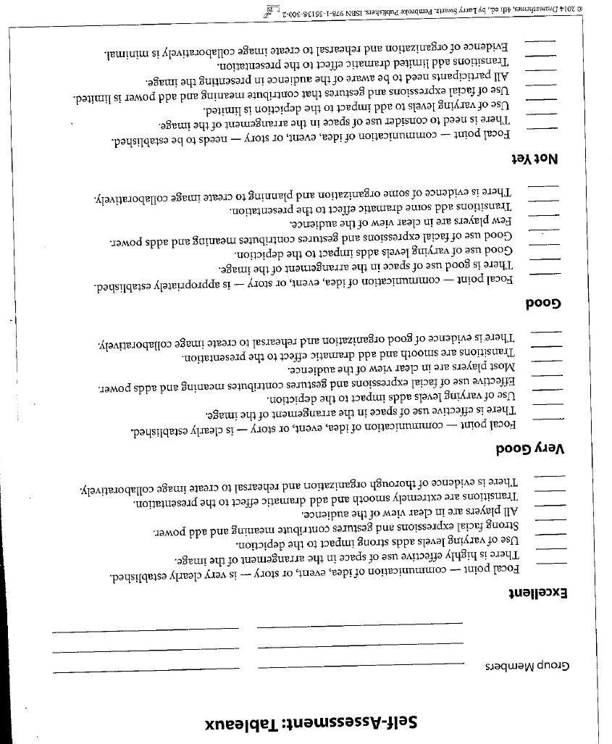

Resources
Arts Education Drama K-7. (n.d.). Retrieved November 19, 2020, from https://www.bced.gov.bc.ca/irp/course.php?lang=en
BC's New Curriculum. (n.d.). Retrieved November 19, 2020, from https://curriculum.gov.bc.ca/curriculum/english-language-arts/5
BC's New Curriculum. (n.d.). Retrieved November 19, 2020, from https://curriculum.gov.bc.ca/curriculum/physical-health-education

Frederick. (n.d.). Retrieved November 19, 2020, from https://books.google.ca/books/about/Frederick.html?id=weWrosinCukC

Johnson, , McKenah. (2017, Mar. 20). Frederick by Leo Leonni Children's Book Read Aloud
[Video].Youtube. https://www.youtube.com/watch?v=X79yh3R65bc

Miller, C. S., & Saxton, J. (2016). Into the story 2: More stories! More drama! Bristol, UK: Intellect.
Swartz, L. (2014). Dramathemes. Markham, Ontario: Pembroke.

Frederick by Leo Leonni
(not exact transcription, taken from https://www.youtube.com/watch?v=X79yh3R65bc)

If the Colour Fits

All along the meadow where the cows grazed and the horses ran, there was an old stone wall.

In that wall, not far from the barn and granary, a chatty family of field mice had their own home. But the farmers had moved away, the barn was abandoned, and the granary stood empty.

Since winter was not far off, the little mice began to gather corn and wheat and straw. They all worked day and night, all except Frederick.

Sculpting (Visualizing the story)

“Frederick, why don’t you work” they asked?

“I do” said Frederick, “I gather sunrays for the cold, dark winter days”.

And when they saw Frederick sitting there, staring at the meadow they said, “And now Frederick?”.

“I gather colours” answered Frederick simply, for winter is gray.

And once Frederick seemed half asleep, “Are you dreaming Frederick?” they asked reposefully

But Frederick said “Oh no, I am gathering words. For the winter days are long and many. And we will run out of things to say”.

Tableau 1 (Frozen in time) & Tap in (Making the picture speak)

The winter days came, and when the first snow fell the five little field mice took their hideout in the stones. In the beginning there were lots to eat, and the mice told stories of foolish foxes and silly cats. They were a happy family.

But little by little they had nibbled up most of their nuts and berries and the straw was gone and the corn was only a memory. It was cold in the wall and no one felt like chatting.
Then they remembered, Frederick had said about the sun rays, and the colours and the words.

Writing in role (In the cold) & Sculpting 2 (What will happen next?)

“What about your supplies Frederick” they asked.

“Close your eyes” said Frederick as he climbed on a big stone. “Now I send you the rays of the sun, do you feel how their golden glow” And as Frederick spoke of the sun, the four little mice began to feel warmer.

Was it Fredericks voice? Was it magic?

“And how about the colours Frederick” they asked anxiously.

“Close your eyes again” Frederick said.

And when he told them, of the blue periwinkles and the red poppies, and the yellow wheat, and the green leaves, and the berry bush. They saw the colours as clearly as if they had been painted in their minds.

Mind Painting

“And the words frederick”

Frederick cleared his throat, waited for a moment, and then, as if from a stagem he said: “Who scatters snowflakes, who melts the ice, who spoils the weather, who makes it nice, who grows the four leaf clovers in June, who dims the daylight, who lights the moon?

Four little field mice who live in the sky.
Four little field mice like you and I.

One is the spring mouse, who turns on the showers.
Then comes the summer who paints in the flowers.
The fall mouse is next with walnuts and wheat.
And winter is last...with little cold feet.
Aren’t we lucky the seasons are four?
Think of a year with one less….or one more?

When Frederick had finished they all applauded!

“But Frederick,” they said “you are a poet!”

Frederick blushed, took a bow, and said shyly “I know it”.

The end!

